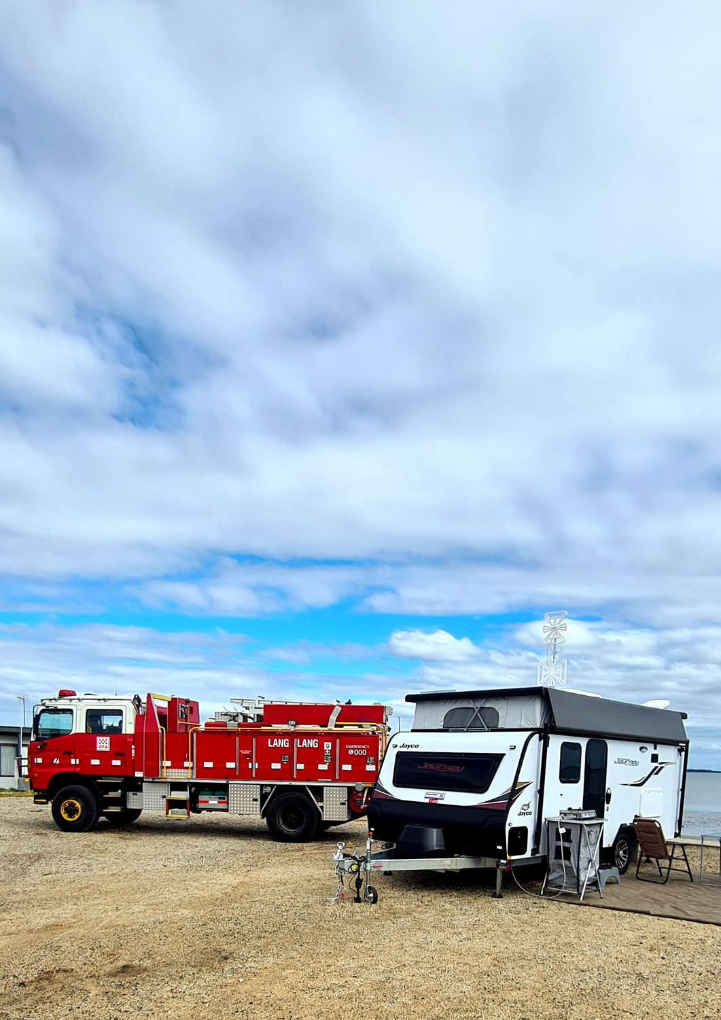

Caravan Park Fire Safety Guidelines
CFA’s minimum requirements for Tourist and Residential (Part 4A) parks

January 2026
CFA Specialist Risk and Fire Safety Unit

Version Control
February 2026
Update to LP Gas cylinder locations.
2.3
Formatting updated for readability; Provision reference numbers included; new January 2026 LEV definition; smoke alarm referenced documentation updated for consistency;
hydrant provisions for residential parks revised; non-reticulated water supply wording updated for clarity; fire separation requirements updated; electric vehicle prescriptive provisions revised; new EV and LEV charging policy prescriptive provision; RMP provision included.
2.2
May 2025
Update to “Who is this Guideline for” section for clarity.
2.1
Date
April 2024
Description
Public release.
Version
2.0



© State of Victoria (Country Fire Authority) 2024

The work contained in this publication is licensed under a Creative Commons Attribution 4.0 licence, http://creativecommons.org/licenses/by/4.0/. You are free to re-use the work under that licence, on the condition that you credit the State of Victoria (Country Fire Authority) as author, indicate if changes were made and comply with the other licence terms. The licence does not apply to:

Any branding, including Country Fire Authority (CFA) and Government logos Any photographs and images, and
Any content supplied by third parties.

CFA makes this information available on the understanding that you take reasonable care when using it. If you have any uncertainty about the application of the information to your particular circumstances, you should obtain professional advice.

CFA does not accept responsibility for how you apply or rely on the information in this publication.

Foreword
CFA plays a vital part in ensuring the risk to life and property from fire is minimised in the country area of Victoria. To enable this, CFA has legislative responsibilities and obligations under various Acts and Regulations, with the intent of protecting lives and property from fire.


Caravan parks are an iconic part of the Australian landscape and have become major providers of short and long-term accommodation. Parks provide a variety of self-contained cabins, powered sites for tourist caravans and tent sites for camping enthusiasts. Many also provide an affordable holiday-home alternative. Others provide residential villages for permanent living, with a strong sense of community. CFA recognises the diversity of caravan parks in siting, design, occupancy and operational activities, and that fire safety risks and resources in caravan parks can vary dramatically across our Victoria.

The intent of this guideline is to improve safety in all caravan parks and sites subject to the Residential Tenancies Act 1997, whether they provide short-term tourist van sites, residential villages, or holiday-home accommodation. This updated edition of the CFA Caravan Park Fire Safety Guidelines responds to an ongoing need within the caravan park community to provide a safe environment for occupants and provide firefighters with the ability to safety and effectively respond to emergencies. It provides a consistent framework to address identified fire risks in both new and existing caravan parks.


CFA would like to acknowledge the support provided by Caravan and Residential Parks Victoria (formerly the Victorian Caravan Parks Association), the Municipal Association of Victoria and various Victorian government departments and agencies for their support with the review of these guidelines.
Jason Heffernan CFA Chief Officer

Content Guide
Preamble Introduction
Who is this guideline for? What’s new in this version? How do I use this guideline? Legislative compliance
Greenfield developments and new works in existing parks Consultation with CFA
Definitions
5
5
6
6
6
7
7
8
Part 1: CFA standards of design, construction and installation Section 1: Firefighting equipment
  - : Occupant fire equipment
  - : Fire authority equipment
Section 2: Access
  - : Firefighter access
  - : Fire vehicle access
Section 3: Fire separation
  - : Fire separation
Section 4: Fire hazards
  - : Bushfire and grassfire
  - : Dangerous goods
  - : Electrical safety
  - : Electric vehicles
  - : Renewable energy installations
10
10
11
14
14
17
23
23
26
26
27
30
31
33
Part 2: CFA standards of management, maintenance and emergency planning Section 5: Risk management
  - : Risk management plan
Section 6: Emergency planning
  - : Emergency management plan
  - : Emergency warnings
Section 7: Maintenance
  - : Maintenance
Section 8: Fire Safety Reports
  - : Schedule of works
34
34
35
35
36
37
37
38
38
Supporting Information
Appendix A: Application of the caravan park guidelines
1. Where the CFA guidelines support compliance with the regulations
Appendix B: References and resources
39
39
40
Please Note:
This document, the CFA Caravan Park Fire Safety Guidelines 2024, supersedes the CFA Caravan Park Fire Safety Guidelines 2012.

Introduction
Within the state of Victoria, the construction, site layout and facilities within caravan parks are regulated by the Residential Tenancies (Caravan Parks and Movable Dwellings Registration and Standards) Regulations 2024 (the Regulations). The Regulations are given effect by the Residential Tenancies Act 1997 (the Act).
Fire Services in Victoria
Within the state of Victoria, there are three fire services responsible for fire suppression, prevention and emergency management.
Country Fire Authority (CFA) is a volunteer-based fire service that operates in the country area of Victoria (CAoV). The CAoV means that part of Victoria which lies outside the Fire Rescue Victoria fire district, but does not include any forest, national park or protected public land.
CFA focuses on fire protection for peri-urban and rural communities, including bushfire management, structural fire suppression, community education, and emergency response.
CFA works closely with local communities, providing fire safety information, conducting fire prevention programs, and coordinating firefighting efforts during emergencies.
Fire Rescue Victoria (FRV) serves metropolitan Melbourne and its urban outskirts, and some large regional cities across Victoria. It is a fully career firefighting service that primarily focuses on structural firefighting, hazardous materials incidents, and urban fire safety.
FRV responds to fires, rescues, and other emergencies in urban areas, including residential, commercial, and industrial buildings.
Forest Fire Management Victoria (FFMV) reduces the risk and impact of bushfires on Victoria's parks, forests and other public land.
The fire services work in collaboration with other emergency services, such as Victoria Police and Ambulance Victoria to provide a coordinated response to emergencies.
The Regulations require compliance with the CFA guidelines. However, caravan parks within the FRV fire district should have regard to any advice from FRV regarding caravan park fire safety.
In relation to fire safety, the Regulations provide for:
- Standards of design, construction and installation and maintenance of movable dwellings in caravan parks.
- Standards for facilities and services in caravan parks.
- The health and safety of residents and short term occupiers of caravan parks.
The Regulations reference CFA’s Caravan Park Fire Safety Guidelines (the CFA guidelines) for technical specifications and methods for achieving fire safety compliance. The CFA guidelines represent an appropriate method for establishing the minimum requirements for fire safety and emergency management to comply with the Act and the Regulations.
The Country Fire Authority Act 1958 imposes a legal obligation on CFA to take all necessary steps for the prevention and suppression of fires and for the protection of life and property in case of fire in the country area of Victoria.

Who is this guideline for?
The CFA guidelines assist designers of new caravan parks, and owners and operators of existing caravan parks, to meet the requirements for fire safety when designing new or redeveloping existing caravan parks throughout Victoria.
Caravan parks (or parts thereof) operating prior to 29th June 2024 can continue to comply with the provisions of the CFA Caravan Park Fire Safety Guideline 2012.
The CFA guideline applies to:
- New caravan parks.
- Established caravan parks with new works.
- New land lease developments (e.g., residential parks) that require registration under the Regulations.
- Existing land lease developments that require registration under the Regulations with new works.
- Any other sites that require compliance with the CFA guidelines.

What’s new in this version?
This update builds on the CFA Caravan Park Fire Safety Guidelines 2012, developing and refining previous advice based on findings from CFA’s extensive inspection and approval regime across the state over more than a decade.
Recognising the community need for a flexible and workable approach to achieving compliance, and ensuring that a consistent approach is applied state-wide, this guideline sets realistic fire safety objectives that must be met through performance measures, which are mandatory minimum standards for fire safety.
The performance measures are achievable through the application of prescriptive provisions, or where existing sites are unable to meet these provisions, development of evidence-based risk controls that provide an equivalent level of fire safety to the satisfaction of CFA.
Land lease developments, commonly referred to as residential parks or lifestyle developments, are now commonplace. Part 4A of the Residential Tenancies Act 1997 regulates long-term land lease arrangements for unregistrable movable dwellings.
Under Part 4A, a land lease development is a residential park that provides long-term occupancy of a site for a unregistrable movable dwelling.
This guideline is applicable to residential parks and has been designed to provide protections for residents of land lease developments, while also ensuring that park operators are able to effectively manage and maintain the park to a high standard.
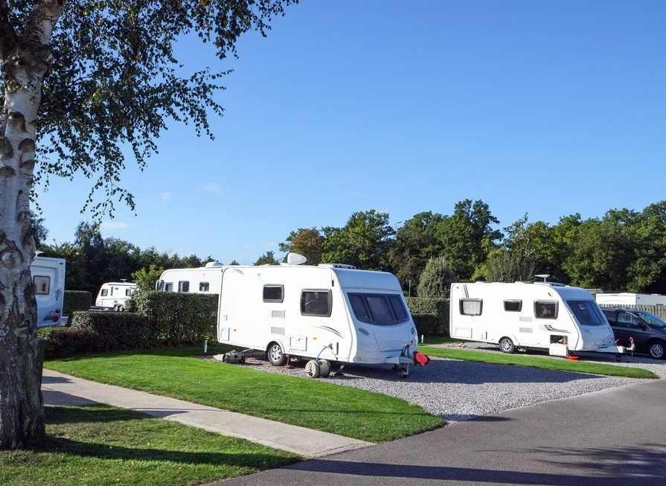

How do I use this guideline?
To protect lives and property from fire, fire risk must be identified and managed at all caravan parks. CFA has developed fire risk management objectives that must be met. This guideline provides the mandatory minimum standards for meeting the objectives, by facility type.

Facility Types
Indicates requirements for all caravan parks.
All Parks
Indicates requirements for tourist parks only.
A tourist park means a caravan park (or parts of the park) which includes long-term sites, short-term sites, or sites for non-residential purposes.
Tourist Parks
Indicates requirements for residential parks only.
A residential park means a caravan park or land lease village (sometimes referred to as a lifestyle village) where land is rented or leased to residents under Part 4A site agreements.
Residential Parks

Where there’s a combination of short-term, long-term and residential sites within the one park (a ‘mixed use park’), the prescriptive provisions for a Tourist Park should be applied.
Where requirements apply to types of parks with particular characteristics (such as ‘reticulated water’), this is specified in the facility type banner:
All Parks - Reticulated Water
All Parks - Non-Reticulated Water

Legislative Compliance
It is the responsibility of caravan park owners to ensure that the legislative requirements are met, and the caravan park is operated in accordance with the registration issued by the responsible authority.
Compliance with legislative requirements must be achieved regardless of whether performance measures or prescriptive provisions are used.

Greenfield Developments and New Works in Existing Parks
To ensure the intent of the CFA guideline is met and to
promote continual improvement in fire safety, CFA’s expectation is that any new works meet the prescriptive provisions. There are no preexisting constraints for these sites that would limit compliance with these measures and intent of the objectives.
Alternative risk controls will not be considered.

Existing Parks
Existing parks (or parts thereof) operating prior to 29th June 2024 can continue to comply with the provisions of the CFA Caravan Park Fire Safety Guideline 2012.

Planning Considerations
State planning policy at Clause 13.02 within the Victoria Planning Provisions (VPPs) requires bushfire to be considered in all planning applications in designated bushfire prone areas (BPA) and the Bushfire Management Overlay (BMO). For new works in caravan parks, applicants need to consider how they will mitigate the bushfire risk at the planning stage.
While the Regulations exempt UMD’s from a Bushfire Attack Level (BAL) construction standard, for higher risk sites such as those within the Bushfire Management Overlay (BMO), CFA recommends considering applying construction standards as part of your bushfire risk management strategy.
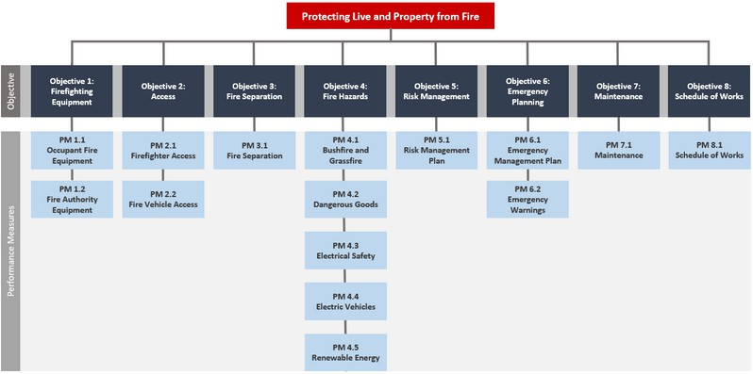
In areas where there is a bushfire risk (including grassfire), emergency planning must take this into consideration (refer to Section 6).

Consultation with CFA
Councils generally seek the advice of the relevant fire authority in considering whether or not a caravan park owner has complied or is complying with fire and emergency management objectives, performance measures and prescriptive provisions of the CFA guideline.
Councils are required to have regard to the most recent report of the relevant fire authority in relation to the caravan park. Consultation with CFA by designers, owners, and operators prior to, during and following the development of reports under the Regulations may be required.
If a Tourist Park or Residential Park development meets all applicable prescriptive provisions, this is considered as deem-to-satisfy. Consultation with the fire service is not necessary during the design phase, unless required by a prescriptive provision. However, initial and periodic inspections and reporting by CFA to ensure the fire safety measures are being met is still required (refer to Section 8).
For existing sites, where risk controls other than the prescriptive provisions are used to meet the performance requirements, these must be to the satisfaction of CFA. Greenfield developments and new works in existing parks must meet the prescriptive provisions.

Figure 0: CFA Caravan Park Fire Safety Guideline 2024 roadmap.

Definitions
The Act means the Residential Tenancies Act 1997.
Allowable encroachments include:
- Non-combustible fascias, gutters and downpipes
- Light fittings, electricity meters, aerials, antennas
- Pergolas, sun blinds
- Unroofed and unwalled terraces, decks, landings, steps, and ramps, not more than 1 m in height
- Fence posts and rails
- Clothes lines
- Pedestrian gates
- Wall mounted hot water service, maximum 210mm deep
It does not include:
- Carports
- LP Gas cylinders
- Gas meters
- Hot water services and systems other than permitted above
- Water tanks
- Air conditioning units / condenser units
- Garden beds, pot plants, and the like
- Any structure or object that would impede access which has not been explicitly defined above
Battery Energy Storage System (BESS) has the same meaning as defined by CFA’s Design Guidelines and Model Requirements for Renewable Energy Facilities.
Caravan Park has the same meaning as defined by the Residential Tenancies Act 1997.
Demarcation line means the boundary between residential sites. This may be defined by a fence but not always.
Electric Vehicle Supply Equipment (EVSE) means the equipment that gets the electricity from the fixed wires in the building to the vehicle. This is better known as an EV charger. Chargers come in three levels (Level 1, Level 2 and Level 3) that affect charging speed and the required equipment and cables.
Fire brigade operations means all firefighter activities from the time of arrival at an incident, including set-up, search and rescue, fire attack, extinguishment, and overhaul.
Habitable structure means a structure which contains one or more habitable rooms, as defined in the National Construction Code.

Ignition source means a source of energy sufficient to ignite a flammable atmosphere, including naked flames, smoking, electrical welding arcs, static electricity and equipment not suitable for use in particular hazardous zones, as defined in Australian Standard 1596-2014: The storage and handling of LP Gas.
Land lease development Under Part 4A, a land lease development is a residential park that provides long-term occupancy of a site for a movable dwelling.
Light electric vehicle (LEV) means personal light electric vehicles such as e-bikes and e-scooters.

Mixed use park means a caravan park with a combination of short-term, long-term and residential sites within the one park.
Movable dwelling means a dwelling that is designed to be movable and includes, but is not limited to, caravans, unregistrable movable dwellings (UMDs), annexes, tents, yurts and the like. It does not include a dwelling that cannot be situated at and removed from a place within 24 hours.
New caravan park has the same meaning as defined by the Residential Tenancies (Caravan Parks and Movable Dwellings Registration and Standards) Regulations 2024.
Part 4A park has the same meaning as defined by the
Residential Tenancies Act 1997.
Part 4A site has the same meaning as defined by the
Residential Tenancies Act 1997.
Regulations means the Residential Tenancies (Caravan Parks and Movable Dwellings Registration and Standards) Regulations 2024.

Relevant fire authority means:
- Country Fire Authority; or
- Fire Rescue Victoria.
Whichever is appropriate to the location of the site.
Residential park / residential village has the same meaning as a Part 4A park.
Responsible authority means the relevant municipal council and is responsible for enforcement of non-compliance with the Act and the Regulations.
Site is any place within the perimeter of the caravan park including those occupied by structures.

Site owner means the person by who owns the site under Part 4A. This is usually the park owner or operator, but not always.

Structure includes a caravan, movable dwelling, unregistrable movable dwelling, yurt (or similar), or an ancillary/service building.
Thermal runaway has the same meaning as defined by CFA’s Design Guidelines and Model Requirements for Renewable Energy Facilities.
Tourist Park means a caravan park (or parts of the park) which includes long-term sites, short-term sites, or sites for non-residential purposes.
Unregistrable movable dwelling (UMD) has the same meaning as defined by the Residential Tenancies Act 1997.
Qualitative means an argument based on comparative reasoning (i.e., expert judgement or opinion).
Quantitative means an argument based on numerical analysis (i.e., design computations or data).
Please Note:
Where legislation, Standards and guidance documents are referenced in this guideline, their use is not precluded where they are updated from time-to-time.

Part 1: CFA standards of design, construction and installation

Firefighting Equipment

Prescriptive Provisions
- Each structure within the residential park must be provided with:
  - Portable fire extinguishers, selected and installed in accordance with AS 2444-2001: Portable fire extinguishers and fire blankets (including signage).
  - Fire blankets selected and installed in accordance with AS 2444 (including signage).
  - Smoke alarms are to be provided in accordance with National Construction Code (NCC) Volume 2 Part 9.5 Smoke alarms and evacuation lighting (hard wired).
- In all other structures occupant fire equipment must be provided as per the NCC.
Residential Parks - PP 1.1R
Objective 1
Appropriate firefighting equipment must be provided within caravan parks to enable:
- Park residents and site tenants to undertake an initial fire attack where safe to do so, and
- The fire service to undertake fire brigade operations, as necessary.

Relevant Regulations:
Regulations 18, 32, 33 and 34

Occupant Fire Equipment

Performance Measure
- Occupant fire equipment must be provided:
  - Appropriate to the identified risks.
  - In locations accessible to all occupants.
  - With compliant signage.

Rationale
Occupants must be notified of a fire as soon as possible and provided with the opportunity to extinguish it or reduce fire spread prior to the arrival of fire services if it is safe to do so.
b. Be provided with protection from the weather.
Each habitable structure within the caravan park must be provided with:
- Portable fire extinguishers, selected and installed in accordance with AS 2444-2001: Portable fire extinguishers and fire blankets (including signage).
- Fire blankets selected and installed in accordance with AS 2444 (including signage).
- Smoke alarms are to be provided in accordance with NCC Volume 2 Part 9.5 Smoke alarms and evacuation lighting (hard wired).
Caravan parks must be provided with fire hose reels that are fit-for-purpose and provide full coverage to all sites when fully extended and laid to avoid any physical barriers.
Fire hose reels are to be installed in accordance with AS 2441-2005: Installation of fire hose reels as if they were being installed to a building, and:
- Be of no more than 36 metres in length.
1.

2.
Tourist Parks - PP 1.1T
Occupant fire equipment must be reliable, effective, and fit-for-purpose. Fire service response times in regional areas can be increased because of distance and resources, therefore occupant intervention may be critical in reducing the size and impact of fire.
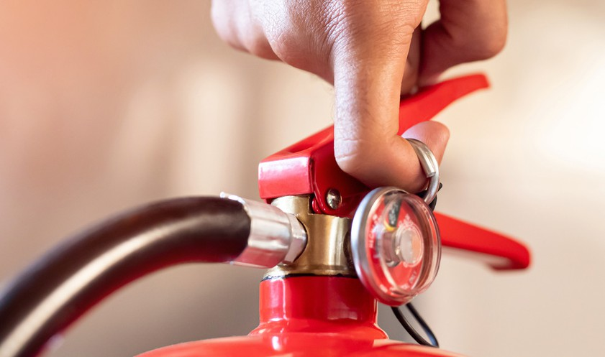

Fire Authority Equipment

Performance Measures
- Firefighting infrastructure must be provided for use by the relevant fire authority:
  - Appropriate to the likely fire services response.
  - Appropriate to the identified risks and hazards.
  - At operable locations acceptable to the relevant fire service.
  - With fittings appropriate to the relevant fire service.
  - With appropriate signage and markers.

Rationale
Fire hydrants are the most effective means of supplying the high volumes of water required by fire brigades. Although responding brigades may include tankers, the amount of water they carry may be insufficient to control or extinguish a fire.
Where reticulated water supply is not available, fire brigades may use on-site stored water or ‘static’ supply. Parks in these areas must provide adequate water to conduct operations to essentially be self-sufficient for the duration of the fire.
As many parks are located within a Bushfire Prone Area, tank/s must be constructed of non-combustible materials in accordance with AS 2419.1-2021: Fire hydrant installations.
Under the Victoria Planning Provisions, non-reticulated residential sites should be provided with adequate water supply for firefighting purposes, generally 10,000 litres.
The provision of 72,000 litres supplied via a hydrant system acknowledges the ‘clustered’ nature of moveable dwellings within caravan parks. Allowing for strategic water supply in this way rather than 10,000 litres per site ensures sufficient water is available.
Hose lengths are determined by operational capacity. Longer lengths create difficulties with set-up time and manoeuvrability and reduce hydraulic performance.
For new development, park operators should engage with CFA at the design stage to ensure the hydrant layout and identification will be acceptable.
For parks with up to 20 sites, consult with CFA regarding design and location of fire water supplies.

Prescriptive Provisions
- A reticulated fire hydrant system is to be provided within the caravan park.
- Hydrants must be provided which:
  - Achieve a flow rate of 10 litres per second at 200kPa at the most disadvantaged hydrant.
  - Pipework and fittings are designed and installed as per AS 2419.1- 2021: Fire hydrant installations for an external on-site fire hydrant.
- The maximum distance between these hydrants and the rear of all structures and/or sites must be 60 metres and the hydrants must be no more than 120 metres apart. These distances must be measured around site boundaries, demarcation lines, buildings, obstacles and the like.
- Above ground hydrants must be identified as applicable to the satisfaction of the relevant fire authority.
- Below ground hydrants must be identified with marker posts and road reflectors as applicable, to the satisfaction of the relevant fire authority.
All Parks - Reticulated - PP 1.2a
1. Above or below ground hydrants operable hydrants must be provided as per AS 2419.1-2021: Fire hydrant installations for an external on-site fire hydrant.
Residential Parks - PP 1.2aR
1. Above ground hydrants operable hydrants must be provided as per AS 2419.1- 2021: Fire hydrant
installations for an external on-site fire hydrant.
Tourist Parks - PP 1.2aT
Further Guidance
CFA’s requirements for identification of hydrants are specified in ‘CFA’s Identification of Street Hydrants for Firefighting Purposes’.

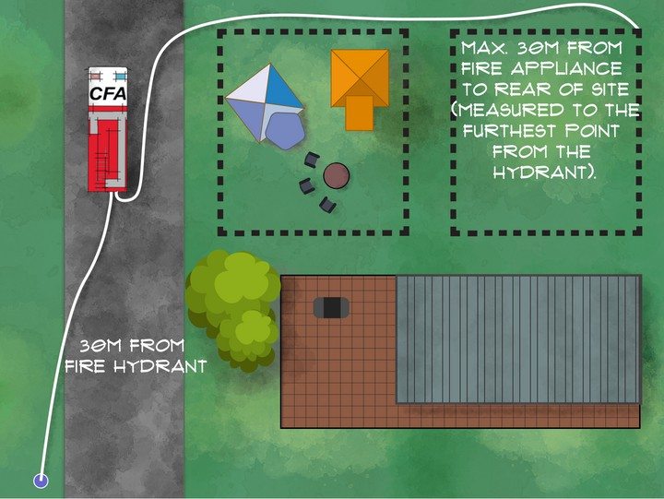
All Parks - Non-Reticulated - PP1.2b
- An external feed hydrant system with a static water supply must be provided in the park as specified below.
Design
  - A minimum water supply of 72,000 litres which:
    - Is stored in an above-ground water tank or tanks, constructed of concrete or metal and is fit for purpose.
    - Includes a large-bore suction with Storz tree, and incorporates a vortex inhibitor.
    - Pipe size and fittings as per AS 2419.1-2021: Fire hydrant installations requirements.
  - Where there are structures greater than 500m2 the fire water supply capacity must
provided in accordance with the National Construction Code.
Performance
  - A flow of 10 litres per second at 200kPa at the most disadvantaged hydrant.
  - A single diesel pump that meets the above performance and incorporates an auto-start on water pressure drop.
Location
e. The maximum distance between these hydrants and the rear of all structures and/or sites must be 60 metres and the hydrants must be no more than 120 metres apart. These distances must be measured around site boundaries, demarcation lines, buildings, obstacles and the like.

Figure 1: Typical hydrant layout design.

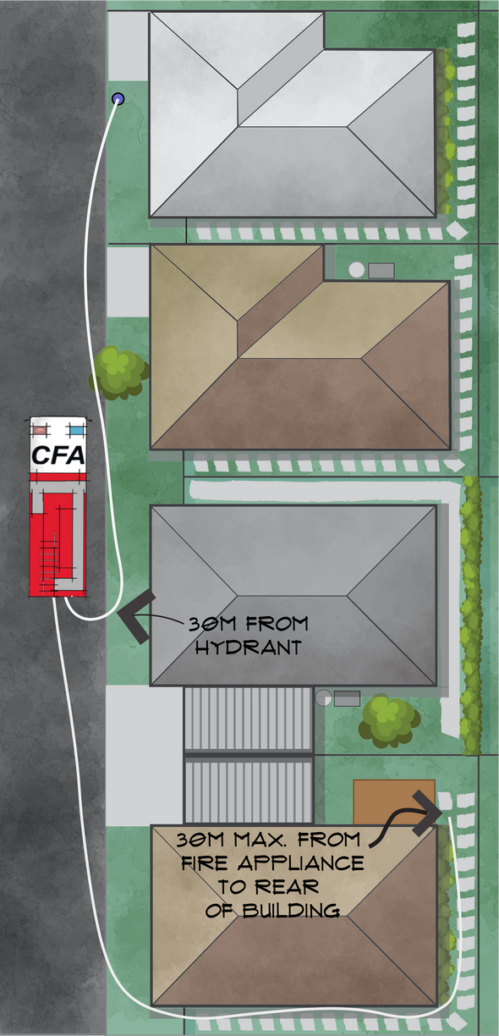
Figure 2: Hydrant layout design.

Access

Objective 2
Adequate access must be provided within caravan parks for:
- Firefighters, between and around any structure.
- Fire vehicles, including pumpers and tankers.

Relevant Regulations:
Regulations 19, 32 and 33

Firefighter Access

Performance Measure
- Access for firefighters must be provided to ensure that they are able to:
  - Travel externally and directly in pairs to the front and rear of a structure in full structural personal protective equipment (PPE), including breathing apparatus.
  - Travel unobstructed on a suitably trafficable surface.
  - Undertake firefighting activities as required.

Rationale
A minimum 1000mm unobstructed width must be provided, which is consistent with the Regulation 79(2) of the Building Regulations 2018. This width supports external fire attack and the use of offensive and defensive firefighting tactics.
Firefighter access and fire separation are separate considerations. Regulation 19 requires access to be in accordance with the CFA Guideline, and Schedule 3 of the Regulations notes that:
“… separation for movable dwellings is in accordance with the CFA Guideline rather than the BCA”.

The Regulations privilege the need for firefighter access requirements over what may be acceptable for a normal dwelling.
Qualitative analysis has often been used to seek a reduction in this requirement, drawing on the fire separation requirements of the NCC of 900mm for a Class 1a dwelling. It has also been argued that doorways are generally 820mm in width and therefore 900mm is acceptable for firefighter access.
In practice, as identified through CFA’s inspections, clear and unobstructed firefighter access is not always provided and maintained as intended, especially in and around unregistrable moveable dwellings (UMDs).
Obstructions such as air conditioning condenser units, hot water services, bins, garden sheds, LP Gas cylinders, landscaping and general storage are commonly found within the intended firefighter access.
Limiting external access means firefighters will have fewer options to undertake rescue operations or suppress the fire.

Prescriptive Provisions

- Firefighter access of 1000mm unobstructed width and 2100mm clear height to the front, one side and the rear of the structure.
- A suitably trafficable surface is provided.
- The clear access must be maintained at all times.
All Parks - PP 2.1

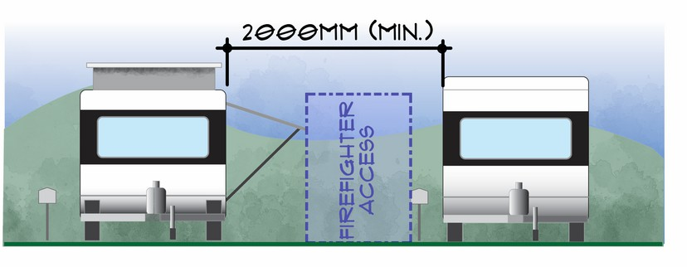

Figure 3a: Firefighter access requirements (between caravans).

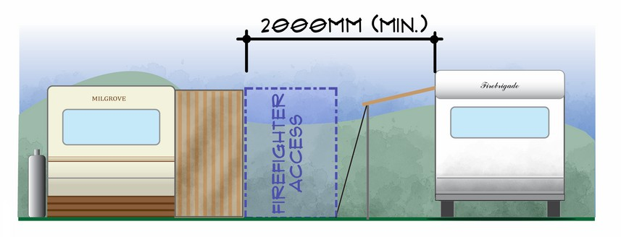
Figure 3b: Firefighter access requirements.

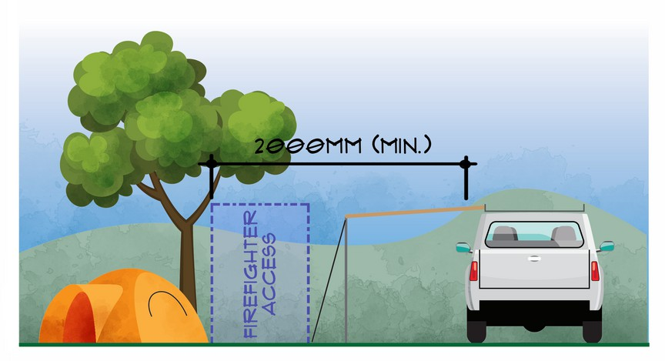
Figure 3c: Firefighter access requirements.

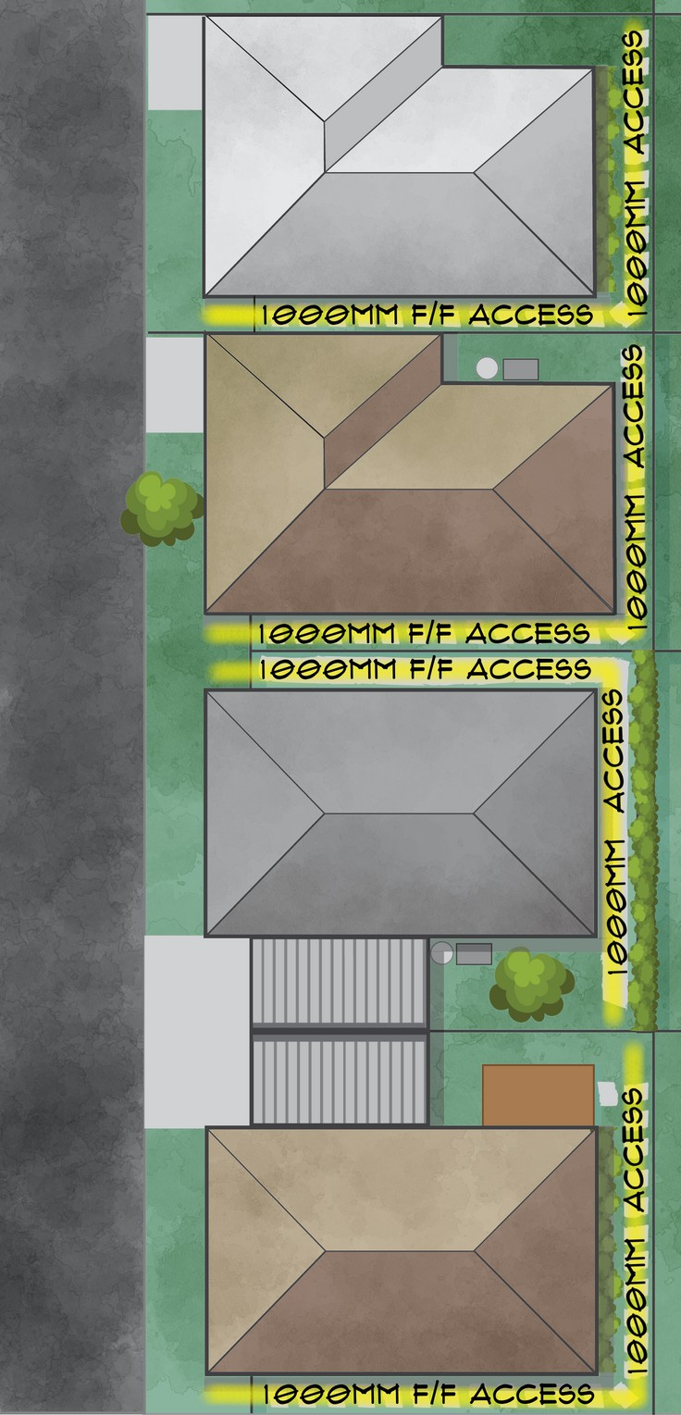

Figure 3d: Firefighter access to the front, one side and rear of the structure.

Fire Vehicle Access

Performance Measure
h. If the access road is a single lane (e.g., less than 5.5m trafficable width)and more than 200m from the nearest intersection it must also incorporate passing bays at least every 200m which must be at least 20m long and have a minimum trafficable width of 6m.
2. Minimum trafficable access road widths must be provided as follows:
3.5 m, with no parking on either side (with appropriate signage restricting parking on both sides) OR
5.5 m with parking on one side (with appropriate signage restricting parking on one side, refer to Figure 5) OR
7.3 m with parking on both sides (refer to
Figure 6).
- Site plans must be provided at every vehicle entrance point to the caravan park, be legible at all times, and include:
  - Access road network and access road names.
  - Site layout and numbering.
  - Water supply and hydrant locations.
- Road signs must be provided.
- Access for fire vehicles must be provided to enable:
  - Access for firefighting vehicles as required.
  - Firefighting operations to be conducted within any part of the caravan park from the fire appliance as necessary.

Rationale
Steep slopes and severe short dips and tight curves affect the free movement of fire trucks and limit operational capabilities. Roads must be trafficable in all weather conditions and should be constructed to suit a 15-tonne Gross Vehicle Mass (GVM).
It is dangerous for emergency services vehicles to reverse along roads for excessive distances, especially in an emergency situation. Access roads must incorporate the ability for fire trucks to execute a three-point turn safely and permit other emergency services vehicles to pass.
Roads designed for an AustRoads 8.8m service vehicle typically align with CFA’s requirements.

Prescriptive Provisions
- Fire vehicle access must be provided within a caravan park as follows:
  - Access roads must have a load limit of at least 15 tonnes.
  - Curves must have a minimum inner radius of 10m.
  - The average grade must be no more than 1 in 7 (14.4 per cent) (8.1 degrees) with a maximum of no more than 1 in 5 (20 per cent) (11.3 degrees) for no more than 50m.
  - Have a minimum trafficable width of 3.5m of all-weather construction.
  - Be clear of encroachments for at least 0.5m on each side and 4m above the access way (refer to Figures 7, 8 and 9).
  - Dips must have no more than a 1 in 8 (12.5 per cent) (7.1 degrees) entry and exit angle.
  - If the access road is more than 100m from the nearest intersection (eg., a dead-end road) it must also provide:
    - A turning circle with a minimum radius of eight metres, OR
    - Other vehicle turning heads – such as a T or Y head – which meet the specification of AustRoads Design for an 8.8 metre service vehicle.
All Parks - PP 2.2

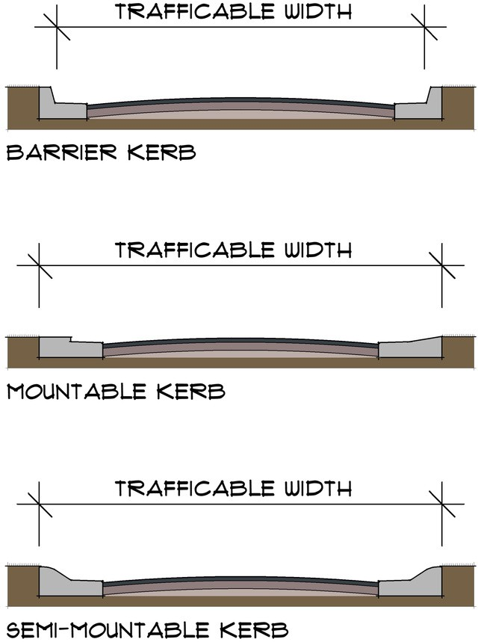
Figure 4: Measuring trafficable width.

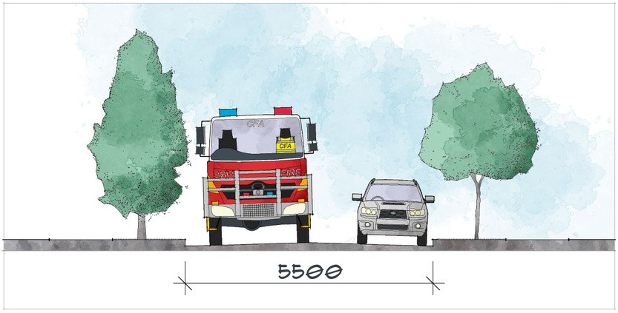
Figure 5: Parking on one side of the street.

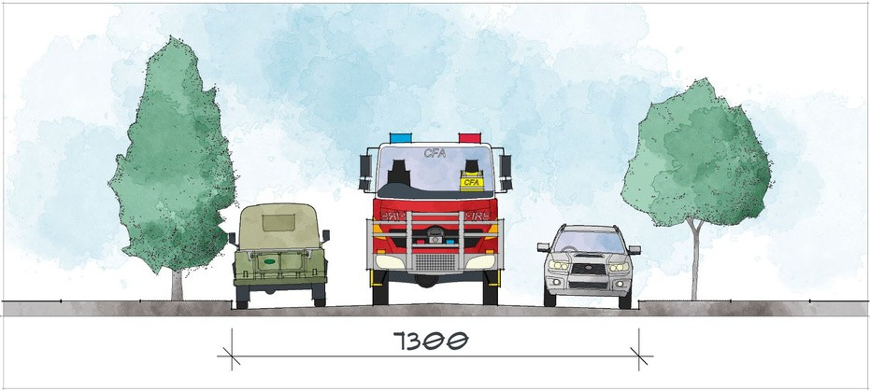
Figure 6: Parking on both sides of the street.

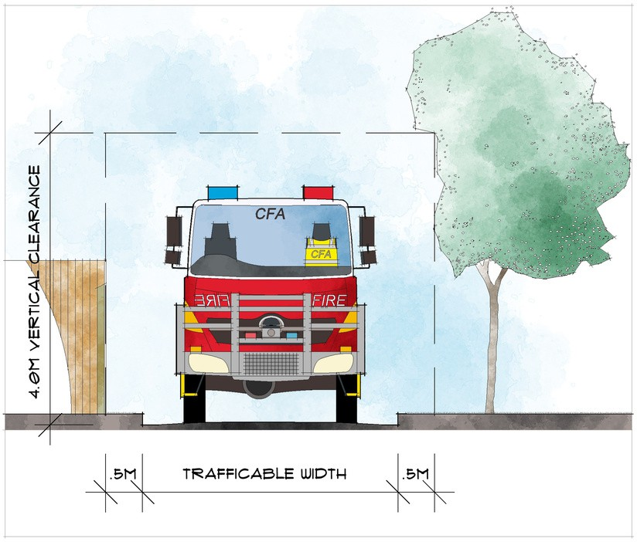
Figure 7: Clearance envelope example.
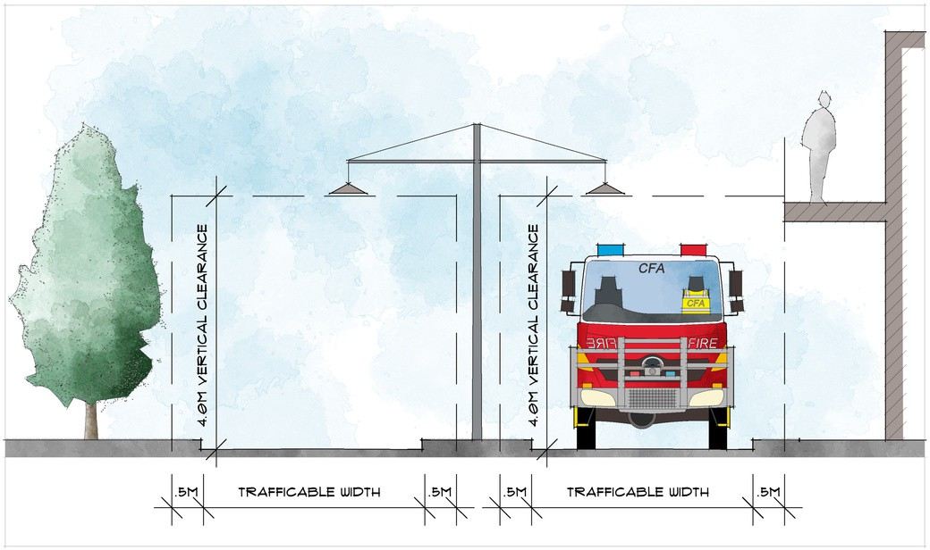
Figure 8: Clearance envelope example.

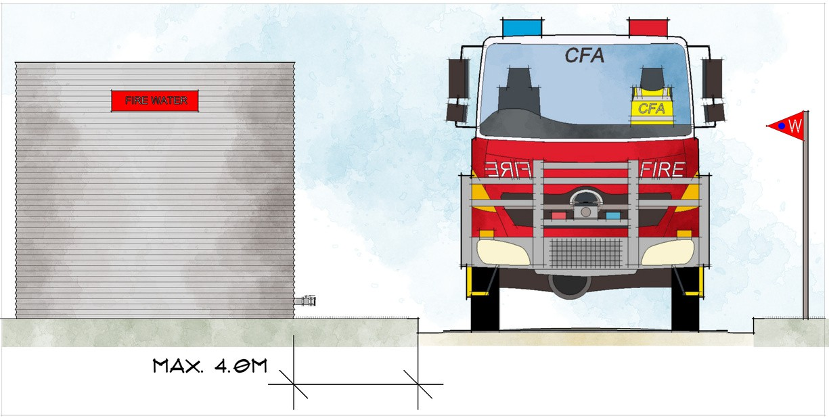
Figure 9: Hardstand access requirement.

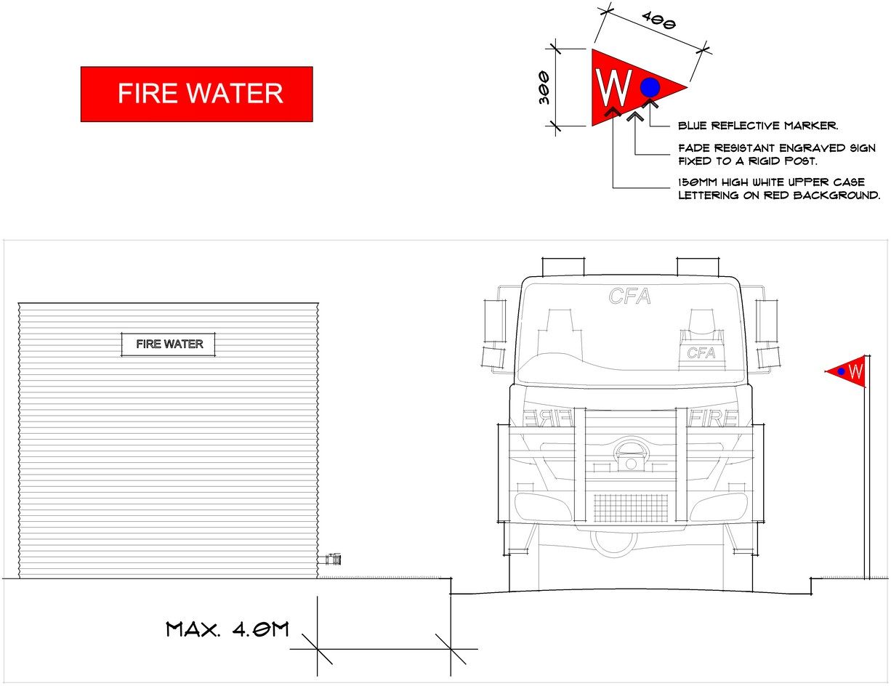
Figure 10: Water supply indicator example.

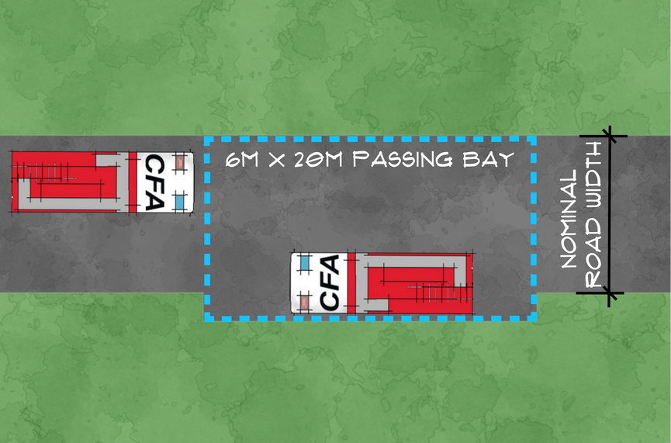

Figure 11: Access road with passing bays.

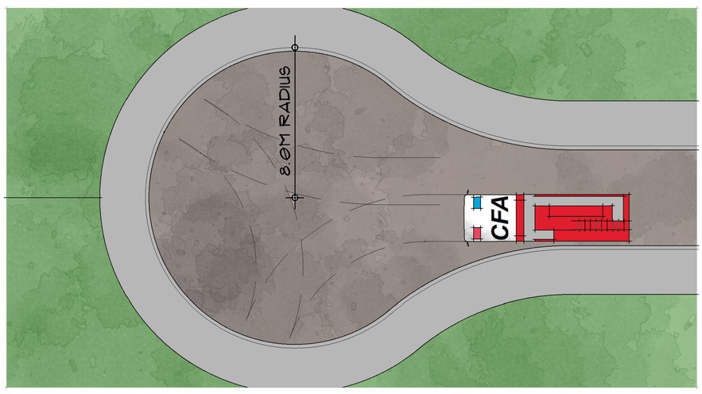
Figure 12: Court bowl turning arrangement.

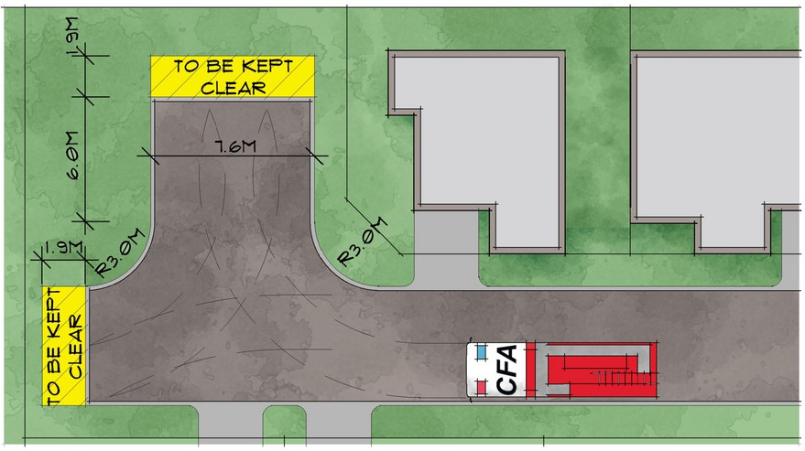
Figure 13: Three-point turning arrangement.
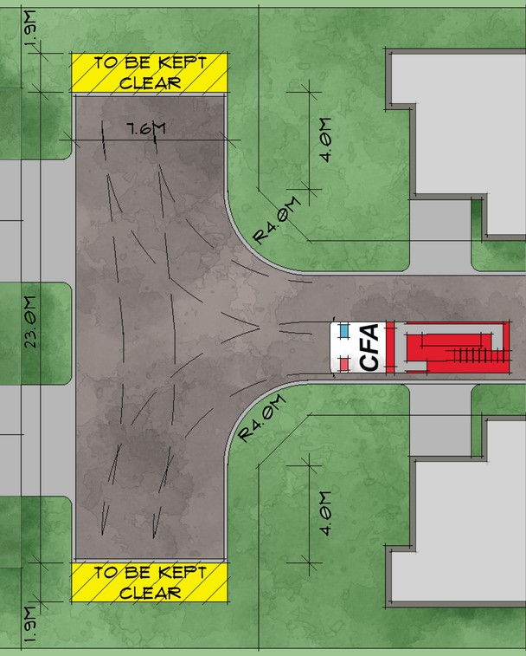

Figure 14: T-head turning arrangement.

Fire Separation

Objective 3
Adequate separation distance must be provided between and around any structure to prevent fire spread so that:
- Occupants can safely evacuate.
- The potential for fire spread to multiple structures is reduced.

Relevant Regulations:
Regulations 19, 32 and 33

Fire Separation

Performance Measure
- All structures must be sited, and clearances maintained to ensure that the likelihood of fire spread between structures is reduced appropriate to:
  - Potential fire intensity.
  - Potential flame contact.
  - Potential radiation.
  - The distance between structures.
  - Fire service intervention.
- All structures must be sited to ensure that occupants can safely evacuate to a designated assembly area in an emergency.

Rationale
Schedule 3 of the Regulations relating to the design and construction of unregistrable movable dwellings and rigid annexes excludes compliance with certain elements of the BCA (NCC) normal to a dwelling, including:
- Objective H3O1(b): Avoid the spread of fire.
- Functional Statement H3F1: Protection from the spread of fire.
- Performance Requirement H3P1: Spread of fire.
- The deemed-to-satisfy provisions contained in clauses H3D3: Fire separation of external walls.
These exclusions mean a UMD does not need to meet the usual, acceptable construction practices of fire resisting walls, use of non-combustible materials and the like that would normally be expected for a Class 1a dwelling.
This is an understandable exclusion considering the portable nature of a UMD, but it means the normal level of robustness of the building fabric cannot be assured.

These exclusions, and that a UMD is also exempt from requiring a building permit, means there is effectively no required construction standard for external walls to prevent the spread of fire. The minimum width for fire separation becomes critical to limit the risk to occupants.
Regulation 19 requires fire separation and firefighter access to be provided, and Schedule 3 notes that:
“Fire separation for movable dwellings is in accordance with the CFA Guideline rather than the BCA.”
One of the key elements of Building Regulations 2018 is to protect a dwelling from fire spread and avoid the spread of fire between dwellings. It is a reasonable community expectation that residents of movable dwellings, caravans and tents within a caravan park or residential village should not be placed at greater risk from fire.
Regulation 79(2) of the Building Regulations 2018 require the minimum setback of a building up to 3.6 metres in height to be 1 metre from the side and rear boundary.
Based on these requirements, a Class 1a dwelling will be no less than 1 metre from the title boundary, except for walls with an FRL of 60/60/60 on or within 200mm the boundary or separating (i.e. party) walls.
The following prescriptive provisions align with the Regulations and the National Construction Code.
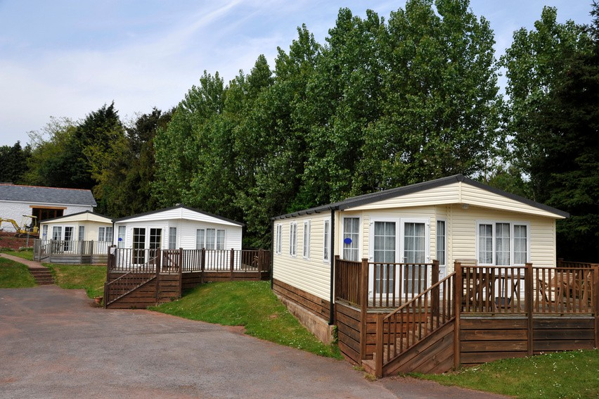

Prescriptive Provisions
- A minimum vertical clearance of 2100mm must be maintained throughout the required fire separation width.
- Vegetation and storage between and around structures that may contribute to fire spread should be reduced and maintained appropriately.
- During the Fire Danger Period:
Grass must be short cropped and maintained.
All leaves and vegetation debris must be removed at regular intervals.
Trees should not touch any elements of buildings.
- Where caravan parks are within the Bushfire Management Overlay, plants greater than 10 centimetres in height must not be placed within 3m of a window or glass feature of the building.
All Parks - PP 3.1
Additional Prescriptive Provisions Based On Facility Type

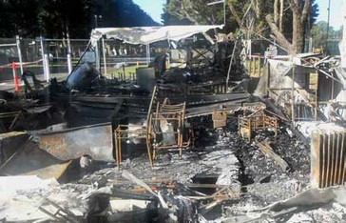
Further Guidance
For information on preparing your property for bushfire refer to How to Prepare Your Property on CFA’s website.
- External walls must be separated by a minimum:
  - 2000mm measured between the external walls of associated structures.
  - 1000mm from any boundary or demarcation line unless the wall is on or within 200mm of the demarcation line.
  - If the wall is on or within 200mm of the demarcation line it must be constructed to an FRL of 60/60/60 in accordance with ABCB Housing Provisions Standard 2022 Part
9.2.
  - If the wall is on or within 200mm of the demarcation line and adjacent to a wall on or within 200mm of the boundary of the (i.e. a partition wall or similar), it must be constructed in accordance with ABCB Housing Provisions Standard 2022 Part
9.3.
- Only one side and the front of the structure may be built on or within 200mm of the demarcation line.
Residential Parks - PP 3.1R
- Fire separation must be minimum 2000mm in width, measured between the external walls of associated structures.
- UMD’s within tourist parks must meet the fire separation requirements of a PP 3.1R.
Tourist Parks - PP 3.1T

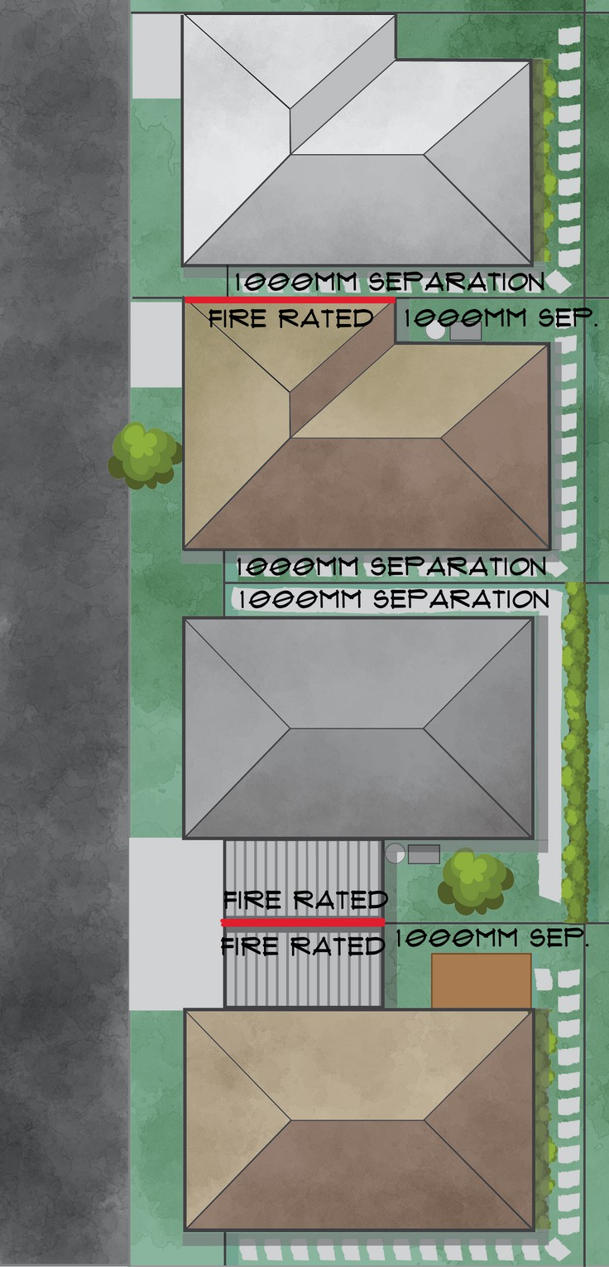

Figure 15: Fire separation between structures.

Fire Hazards

Objective 4
Potential fire hazards must be identified, managed and maintained safely.

Relevant Regulation:
Regulation 20

Bushfire and Grassfire

Performance Measure
1. Bushfire and grassfire risks must be identified and managed.

Rationale
The potential for bushfire and grassfire and the consequences of its impact must be considered by caravan park owners/operators.
Caravan parks may be at risk of bushfire and grassfire if they are:
- Located in an area close to or amongst dense or open bush, unmanaged grassland, near coastal scrub, or at an urban fringe.
- Identified as being in a Bushfire Prone Area, or within the Bushfire Management Overlay.
Caravan park owners/operators must:
- Understand landscape and site fire risk.
- Develop and implement fire risk controls.
- Maintain and review fire risk controls.
- Incorporate bushfire emergency planning into the Emergency Management Plan (refer to Section 6).

Prescriptive Provisions
All Parks - PP 4.1

Understand Landscape and Site Fire Risk
Caravan park owners/operators must:
  - Take steps to understand bushfire risk at the site.
  - Ensure that fire risk controls commensurate to the fire risk are developed, implemented and reviewed.
  - Be proactive in modelling and maintaining a culture of bushfire awareness and safety.
  - Establish and maintain a relationship with the local CFA brigade.
- Develop and Implement Fire Risk Controls Caravan park owners/operators must develop and implement fire risk controls appropriate to the hazards and risks in the landscape. This may include:
  - Fire permits and restrictions - ensuring that fire permits are obtained and followed, and that restrictions based on Fire Danger Ratings or Total Fire Ban status are implemented.
  - Job/task fire risk management - ensuring job hazard analysis processes are developed and implemented that consider site infrastructure, operations and landscape hazards.
  - Vegetation management - ensuring that any accumulation of combustible materials are cleared and removed from site.

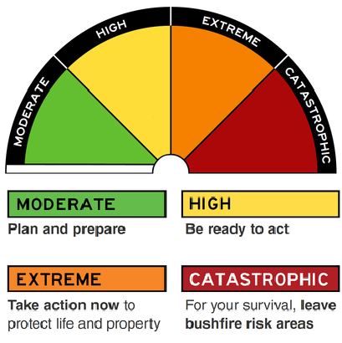
  - Maintenance - ensuring fire protection and
Australian Fire Danger Rating System

The Fire Danger Rating tells you how dangerous a fire would be if one started.
The four-day Fire Danger Rating forecast is available on the CFA website during the Fire Danger Period.
detection systems, plant, vehicles and equipment are regularly inspected and maintained.
  - Inspection of dangerous goods storage and handling areas - ensuring safe and compliant storage and handling practices.
  - Site-wide bushfire preparedness housekeeping inspections - ensuring bushfire-focused inspections are conducted at least three months, and again one month, prior to the Fire Danger Period.

Maintain and Review Fire Risk Controls
Caravan park owners/operators must:
  - Establish and document standards and processes for the appropriateness and effectiveness of fire risk controls.
  - Conduct/update risk assessments where there are changes to the park landscape and operations.

Dangerous Goods
Dangerous goods are substances capable of causing harm to people and property because of their hazardous properties. They may be corrosive, flammable, combustible, explosive, oxidising or water-reactive or have other hazardous properties.
Occupiers of facilities storing and handling dangerous goods must comply with the Dangerous Goods (Storage and Handling) Regulations 2022. Common dangerous goods at caravan parks include LP Gas (in tanks and cylinders), petrol and pool chlorine.

LP Gas

Performance Measure
- LP Gas storage within caravan parks must be managed and maintained appropriate to:
  - Storage size.
  - Storage location.
  - Storage type.
  - Use.

Rationale
LP Gas is commonly used in caravan parks and may be stored in large quantities in tanks or smaller cylinders, often immediately adjacent to accommodation structures. LP Gas is class 2.1 dangerous goods, it is highly flammable and must be stored and used safely.
Caravan Park owners/operators should ensure that:
- The type, location, and orientation of cylinders is in accordance with dangerous goods regulatory requirements and the relevant Australian Standards.
- LP Gas storage areas are clear of ignition sources. Service equipment such as hot water units, gas or electric, air-conditioning units/condensers, or other spark or piloted equipment are considered ignition sources and this equipment should not be located within hazardous areas.
- LP Gas storage areas are provided with fire protection equipment in line with AS/NZS 1596-2014: The storage and handling of LP Gas.
- They understand how LP Gas pressure relief devices and vent discharging pipes operate and the direction that the gas cylinder may vent.
Advice from the fire services may be required to ensure that the fire protection and emergency planning measures are appropriate to dangerous goods risks
on-site. This requirement generally applies to the storage of LP Gas exceeding 5000 litres/kg (refer to Schedule 2 of the Dangerous Goods (Storage and Handling) Regulations 2022.

Prescriptive Provisions
All Parks - PP 4.2.1

LP Gas Locations
- LP Gas storage and use within caravan parks must be in accordance with AS/NZS 1596, AS/NZS 5601.2-2020: LP Gas installations in caravans and boats for non-propulsive purposes, and the Dangerous Goods (Storage and Handling) Regulations 2022.
- Movable dwellings must comply with AS 5601.1, Appendix J: LP Gas cy linder locations, as appropriate.
- LP Gas cylinders that are stored and used within the park must comply with regulations and must be inspected regularly for damage, obstructions and to ensure separation from ignition sources and combustible materials.
- Owners of movable dwellings should also ensure that LP Gas cylinders are stored in a compliant location and secured in such a way that prevents movement.
- LP Gas cylinders must be secured to prevent movement or physical damage.
- Valves must be safeguarded against physical damage in accordance with AS 2473.1-2006: Valves for compressed gas cylinders.
- LP Gas cylinders must not be placed in prohibited locations as per AS/NZS 1596, including:
  - Within a building, except where permitted by AS /NZS 1596.
  - Under a stairway.
  - In a location with restricted access, where inspection, refilling or exchange of the cylinder is restricted, obscured or hazardous to the operator.
  - Where nearby constructions, fences, walls, or vapour barriers could prevent cross-ventilation.
  - Under a building, except where permitted by AS /NZS 1596.
  - Where the cylinder, or an incident involving the cylinder and its contents, could obstruct egress from a building.
  - Buried in the ground, unless the cylinder and gas installation have been specifically designed for such a location.

LP Gas Storage
- If LP Gas or other dangerous goods are stored or handled in quantities that exceed those listed under “Manifest Quantity” or “Fire Protection Quantity” in Schedule 2 of the Dangerous Goods (Storage and Handling) Regulations 2022:
  - Written advice from the relevant fire authority must be sought as per Regulations 52 and 53.
  - Occupiers must have regard to the written advice.
Ignition Sources
- Sources of ignition are not permitted within a hazardous area as per AS/NZS 1596.
All Parks - PP 4.2.1 (Continued)

Figure 16: Exchange LP Gas cylinder location.
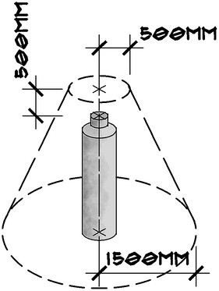
Figure 17: LP Gas cylinder hazardous area.
Adapted from AS/NZS 1596-2014: The storage and handling of LP Gas.

Flammable Liquids

Performance Measure
- Flammable liquids within caravan parks must be monitored and maintained appropriate to:
  - Storage size.
  - Storage location.
  - Storage type.
  - Use.

Rationale
Flammable liquids are class 3 dangerous goods. They are highly volatile and must be stored and used appropriately. Vapours from fuel such as petrol and kerosene are heavier than air and will settle in low spots such as drains.
Caravan Park owners/operators must ensure that flammable liquids storage areas are:
- At least 3 metres away from any dwellings and positioned to prevent a further hazard.
- Provided with fire protection equipment in line with AS 1940-2017: The storage and handling of flammable and combustible liquids.
- Equipped with a means of handling small spills with a non-leaching, biodegradable oil and chemical absorbent.
To Be Updated
Advice from the fire services may be required to ensure that the fire protection and emergency planning measures are appropriate to dangerous goods risks
on-site. This requirement generally applies to the storage of flammable liquids exceeding 2,500 litres (refer to Schedule 2 of the Dangerous Goods (Storage and Handling) Regulations 2022).

Prescriptive Provisions
- If flammable liquids or other dangerous goods are stored or handled in quantities that exceed those listed under “Manifest Quantity” or “Fire Protection Quantity” in Schedule 2 of the Dangerous Goods (Storage and Handling) Regulations 2022:
  - Written advice from the relevant fire authority must be sought as per Regulations 52 and 53.
  - Occupiers must have regard to the written advice.
All Parks - PP 4.2.2

Corrosive Substances

Performance Measure
- Corrosive substances storage within caravan parks must be monitored and maintained appropriate to:
  - Storage size.
  - Storage location.
  - Storage type.
  - Use.

Rationale
Corrosive substances such as pool chlorine and cleaning chemicals are class 8 dangerous goods and must be stored and used appropriately. Corrosive substances may cause severe burns and other injuries if not stored and handled safely.
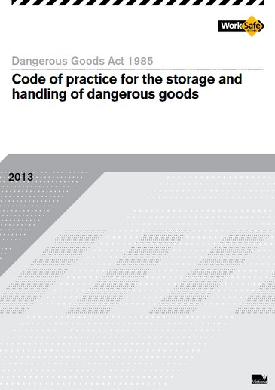
Caravan Park owners/operators must ensure that corrosive substances are:
Further Guidance
WorkSafe’s Code of Practice for the Storage and Handling of Dangerous Goods (2013, revised 2022) contains practical guidance for complying with the Dangerous Goods (Storage and Handling) Regulations 2022).
- Stored and handled in accordance with the requirements of AS 3780-2023: The storage and handling of corrosive substances.
- Stored in secured areas that are not readily accessible to members of the public.
- Stored in a manner whereby any spills or leaks are contained (eg., in a bunded area, and/or with a suitable spill kit nearby).
- Only handled by persons with appropriate training in their safe storage, use and emergency response, who have been supplied with the appropriate personal protective equipment (PPE) and equipment for safe clean-up and disposal.
Advice from the fire services may be required to ensure that the fire protection and emergency planning measures are appropriate to dangerous goods risks
on-site. This requirement generally applies to the storage of corrosive substances exceeding 2,500 litres (refer to Schedule 2 of the Dangerous Goods (Storage and Handling) Regulations 2022).

Prescriptive Provisions
- If corrosive substances or other dangerous goods are stored or handled in quantities that exceed those listed under “Manifest Quantity” or “Fire Protection Quantity” in Schedule 2 of the Dangerous Goods (Storage and Handling) Regulations 2022:
  - Written advice from the relevant fire authority must be sought as per Regulations 52 and 53.
  - Occupiers must have regard to the written advice.
All Parks - PP 4.2.3

Electrical Safety

Performance Measure
- Electrical safety must be implemented and maintained within all caravan parks and structures.

Rationale
Electricity is a major cause of fires worldwide. Electrical fires commonly start due to:
  - The overloading of the power supply by using multiple power boards and/or double adaptors.
  - Powerlines touching each other as a result of falling trees or branches.
Caravan Park owners/operators should promote electrical safety in accordance with AS/NZS 3000-2018: Electrical installations (Wiring Rules) and AS/NZS 3001.1-2022: Electrical installations. AS/NZS 3001.1 is a specific standard for electrical installations in transportable structures such as caravans and other vehicles. This standard also applies to site electrical supplies.
The Victorian Fire Services do not regulate electrical safety. The fire services support the requirements of Energy Safe Victoria and the application of Australian Standards as part of a holistic fire safety approach.

Fire Safety Guidance
CFA recommends that the following are implemented across all parks, and are regularly checked by park owners/operators.
- Power lines must be kept clear of vegetation and other obstructions.
- External power supply between the source and structures within the caravan park must be insulated and not contain any connections exposed to the weather.
- Supply leads must be arranged so that they will not obstruct persons walking in the vicinity of any movable dwelling and are located to provide suitable protection against mechanical damage, damage by high temperatures or ultra-violet radiation.
- Each site should have its own individual power source.
- If connected to mains power the movable dwelling should have its own residual current device.
- The use of multiple power boards and double adaptors should be avoided and discouraged.
- Extension leads for connection between the external power source and the structure should be tested and tagged in accordance with AS/NZS 3760-2022: In service safety inspection and testing of

- Appendix B of AS/NZS 3001.1-2022: Electrical installations specifies that caravan park owners provide connection information to all site occupiers.

Connection Instructions for Caravan Park Patrons
- Do not connect more than one supply lead to each socket-outlet of the site supply.
- Any supply lead used to connect a connectable electrical installation to a site supply socket-outlet should be in one unbroken length.
- The supply of electricity for use in individual connectable electrical installations should not be ontained from a socket-outlet inside another connectable electrical installation or by the use of socket-outlet adaptors (double adaptors).
- Where a supply lead is coiled on or in a reel, drum, storage box or similar, the lead should not be connected to the site supply while coiled.
- Connectable electrical installations should be inspected regularly (e.g., annually), by a competent person to ensure their safe and effective operation.
- Residual Current Devices (RCD) used for the protection of connectable electrical installations should be tested by operating the push button on the RCD to check that the device trips. After tripping, the RCD should be reset. If the RCD fails to trip, this failure should be reported to the caravan park manager.
- The location of the device (within the premises or service pillar) is required for resetting in the event of a loss of supply.
- Avoid placing supply leads in pedestrian ways.
Adapted from AS/NZS 3001.1-2022: Electrical installations, Appendix B: Provision of connection instructions for caravan park or camping ground patrons.

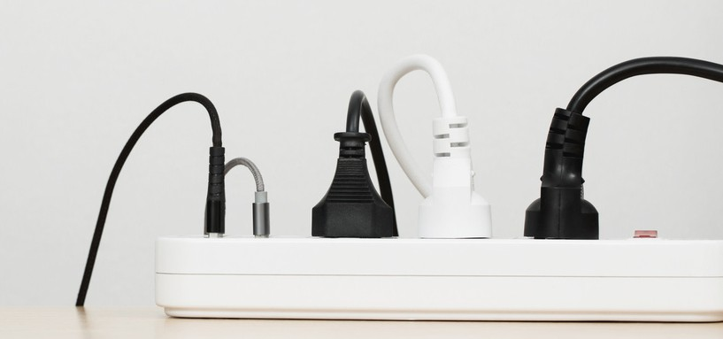

electrical equipment and RCDs.
30

Electric Vehicles

Rationale
Electric vehicles are becoming increasingly popular in Victoria resulting in the rapid provision of EV charging stations in public and private spaces.
Risks for EV charging must be addressed by park owners/operators considering the installation of EV charging stations. Electric shock and fire may result from incorrect installation, electrical faults, mechanical damage, failure of internal systems, overcharging, operating outside of safe temperate limits and insufficient maintenance, among others. The consequences may contribute to harm to persons, property and the environment.

Fire Safety Guidance
CFA recommends that a risk assessment process is undertaken by caravan park owners/operators to ensure that all relevant risks specific to the site and its operations are considered.

CFA recommends that EV charging equipment selected for caravan parks includes:
- Proximity Pilot (PP) and Control Pilot (CP) pins.
- Type-2 socket (entry only).
- Load balancing capabilities.
- Adjustable power rating output.
- An isolator within 1m of the EV charger for quick isolation.
- The ability to program a time-schedule for on/off periods to allow charging only during specified times.
CFA recommends that EV charging equipment is installed:
- In accordance with the relevant Australian Standards, including AS/NZS 3000-2018: Electrical Installations (Wiring Rules) by a qualified electrician.
- Away from vegetation, dangerous goods storages, fire service infrastructure, evacuation assembly areas, waterways or any area that floods.
It is crucial to follow the instructions and guidelines provided by the manufacturers of the electric vehicle and the EV charging station, and to be aware of any faults that arise during the charging process.

Prescriptive Provisions
- Electric Vehicle Charging Stations
Electric Vehicle Supply Equipment (EVSE) must:
  - Be ’smart’ or OCPP chargers that can be remotely monitored if required.
  - Be electrically compliant; in Australia this is the RCM Tick.
  - Only be installed by a suitably qualified electrician.
  - Be maintained as per manufacturer’s instructions.
- Electric Vehicle Charging Stations Associated with a Site
Electric Vehicle Supply Equipment (EVSE) must:
  - Be only of Level 1 or Level 2.
  - Incorporate a load management system.
  - Be provided with adequate protection from impact or mechanical damage.
- Electric Vehicle Charging Stations not Associated with a Site (Communal)
Electric Vehicle Supply Equipment (EVSE) must:
  - Be Level 1 or Level 2.
  - Incorporate a load management system.
  - Be provided with adequate protection from impact or mechanical damage.
  - Be located no less than 10 metres and no more than 60 metres from a hydrant / static water supply outlet.
  - If a Level 3 charger is to be installed, it must also be installed in accordance with the relevant energy distributor requirements.
- Light Electric Vehicle (LEV) Charging Area
If a dedicated LEV powerhead is provided it must:
  - Be installed by a suitably qualified electrician.
  - Be clear of flammable or combustible materials.
  - Be provided with adequate protection from impact or mechanical damage.
  - Be located no less than 10 metres and no more than 60 metres from a hydrant / static water supply outlet.
All Parks - PP 4.4

EV’s and LEV’s must not be charged via a UMD, caravan’s (or similar) internal electrical system
i.e. plugged into a wall socket.
They must only be charged via a properly installed EVSE as detailed in the prescriptive provision.

EV and LEV Charging Policy

Rationale
Risks within the park can be managed through a comprehensive risk assessment, planning, maintenance and management. For charging of EV’s, this may be by providing charging stations that are properly installed and maintained.

When visitors bring and use their own EVSE, you may not know the standard, condition or maintenance of that supply equipment. Park operators might also need to consider the capacity and condition of electrical infrastructure in the park, and what effect ad hoc charging multiple EV’s will have on the systems.

To address this, the park should develop policy to ensure guests and visitors are aware of their obligations to help keep your park safe and enjoyable for all.

Your policy may not necessarily prohibit the use of private EVSE but it should be based on a risk assessment, any fire risk controls deemed necessary, and considers the particular features of the park.

Fire Safety Guidance for Personal Light Electric Vehicles
Personal light electric vehicles include e-bikes and e-
scooters.
CFA recommends that caravan parks introduce dedicated, compliant charging infrastructure and policies for managing the charging of personal light electric vehicles.
CFA recommends that charging infrastructure for light electric vehicles is installed as for electric vehicles as described in Section 4.4.
CFA recommends that policies for charging include:
- That charging only occurs at designated charging points that are managed by the caravan park.
- That bans are placed on the charging of personal light electric vehicles at individual sites.
CFA recommends that charging equipment for personal light electric vehicles includes timed charging of no more than three hours.
Further Guidance
EV Fire Safe conducts, collates and responds to research about electric vehicle high voltage battery fires and emergency response, particularly where the EV is connected to energised charging.

Prescriptive Provisions
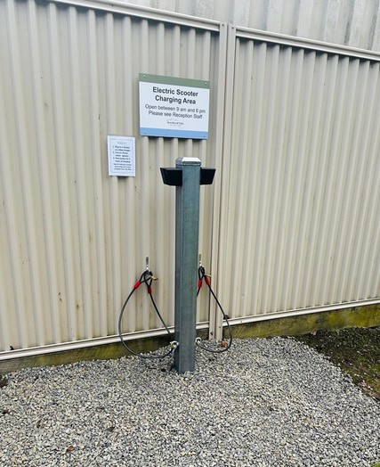
- If EV or LEV charging facilities are provided:
  - Park policy developed and provided to guests to ensure only installed EVSE or dedicated LEV charging areas are used (if provided).
- If EV or LEV charging facilities are not provided:
  - A risk assessment of guests using their own EVSE must be undertaken and documented in the Risk Management Plan.
  - Fire risk controls must be developed based on the risk assessment.
  - Park policy developed and provided to guests to support implementation of the fire risk controls.
All Parks - PP 4.4.1

Personal light electric vehicle charging point at a caravan park. Note the bike locks to secure the LEV while being charged.

Renewable Energy Installations

Rationale
Caravan parks are increasingly adopting renewable energy sources as a means to reduce reliance on the grid and provide backup power during outages. These sources may include solar arrays and battery energy storage systems.
Risks for renewable energy installations must be addressed by park owners/operators considering their installation. Electric shock and fire (from thermal runaway) may result from incorrect installation, electrical faults, mechanical damage, failure of internal systems, overcharging, operating outside of safe temperate limits and insufficient maintenance, among others. The consequences may contribute to harm to persons, property and the environment.
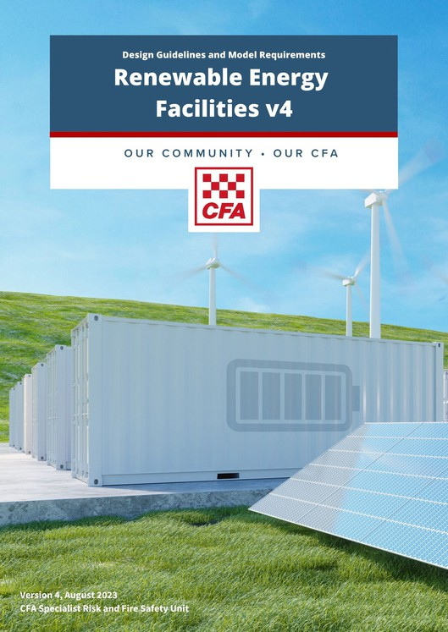
CFA recommends that a Risk Management Plan (RMP) is developed for battery energy storage system proposals, to ensure that all relevant risks specific to the site and its operations are considered. The RMP must be developed in consultation with CFA’s Specialist Risk and Fire Safety Unit.
Further Guidance
Guidance for understanding and managing fire risk at renewable energy facilities is provided in CFA’s Design Guidelines and Model Requirements for Renewable Energy Facilities, and CFA’s Guidance for Neighbourhood Battery Energy Storage Systems.
The requirements of CFA’s Design Guidelines and Model Requirements for Renewable Energy Facilities must be considered for BESS in caravan parks, including:
- Siting of BESS in low-risk areas.
- Provision of monitoring, fire detection and suppression systems, explosive prevention systems.
- Adequate road access to and around the installation for fire brigade vehicles and operations.
As moveable dwellings have exemptions from the National Construction Code, they are potentially vulnerable to the risks associated with BESS, and this must be considered in their siting, planning, design and operation.

Prescriptive Provisions
Battery Energy Storage Systems
- Battery Energy Storage Systems (BESS) may only be installed in movable dwellings and UMDs if permitted by legislation.
- BESS must be installed as per AS/NZS 5139-2019: Electrical installations – Safety of battery sy stems for use with power conversion equipment.
- BESS must be sited, designed and operated in accordance with CFA’s Design Guidelines and Model Requirements for Renewable Energy Facilities.
- Consultation with CFA’s Specialist Risk and Fire Safety Unit must also be sought where battery energy storage systems over 1MW are proposed.
All Parks - PP 4.5

Part 2: Standards of management, maintenance and emergency planning

Risk Management
The following risk factors must be considered in risk assessments for caravan parks:
- Location and Siting within the Landscape
Is the park in a designated Bushfire Prone Area or within the Bushfire Management Overlay?
Is there a risk of grassfire from neighbouring properties?
Is the park within the Land Subject to Inundation Overlay?
Is there peat on the property?
Is the site located near hazardous industries?
- Park Layout
Does the layout of the park impact fire risk? Is fire service infrastructure safely accessible? Are there hazards or infrastructure that may impact safe evacuation?
- Vegetation On-Site
Does the prevalence, type, density or location of vegetation impact fire risk?
- Infrastructure: Electrical, Chemical, Technological
Does the infrastructure on site contribute to fire risk, or potentially impede firefighting operations?
Are dangerous goods stored on-site? Are there electrical hazards on-site?
- Park Activities and Operations
What activities undertaken on-site contribute to fire risk?
How is electricity infrastructure de-energised and isolated?
How often is critical maintenance undertaken?
- Park Occupancy
What is the occupancy of the park? What are the demographics?
Will there be vulnerable occupants?
- Local Weather Conditions
What is the prevailing wind speed and direction? What is the rainfall during the year?
What is the humidity and temperature during the Fire Danger Period?
All Parks - PP 5.1

Objective 5
A risk assessment must be conducted and documented in a Risk Management Plan.

Relevant Regulations:
Regulation 20

Risk Management Plan

Rationale
The Regulations require a risk assessment to be conducted by the caravan park owner in consultation with the relevant emergency service agencies to identify, analyse and evaluate the emergency risks associated with the caravan park.
The risk assessment informs the development of an Emergency Management Plan.
CFA recommends that risk assessments are documented within Risk Management Plans (RMP) where the process and outcomes of identifying, analysing, managing, evaluating and reviewing risks is clearly outlined. The RMP can be included as part of the Emergency Management Plan.

Content of Risk Management Plans
The RMP must:
- Specify the risks identified, analysed and evaluated by the caravan park owner/operator.
- Describe the specified measures to be taken to reduce emergency risks so far as is reasonably practicable, including preventative measures to reduce their likelihood and consequences.
The RMP structure may reflect the framework outlined in AS/ISO 31000-2018: Risk Management - Guidelines.
The prescriptive provisions within this guideline are CFA's minimum requirements (risk controls) for caravan parks and must be reflected in the RMP.

Prescriptive Provisions

Further Guidance
Refer to Section 4 for common hazards at caravan parks. Site-specific hazards must be identified through the risk management process.

Emergency Planning

Objective 6
A site-specific Emergency Management Plan must be developed, implemented and maintained.

Relevant Regulations:
Regulations 20, 22 and 23

Emergency Management Plan

Performance Measures
- An Emergency Management Plan must be developed appropriate to:
  - Caravan park size and characteristics.
  - Number of staff and occupants.
  - Available emergency services.
  - Identified fire risks and hazards (including bushfire).
  - Available egress from the site.
- The Emergency Management Plan must be located in an area that is easily accessible by the fire services.

Rationale
The Regulations require the caravan park owner to prepare an Emergency Management Plan (EMP) in consultation with the relevant emergency services.
An EMP is an essential fire risk management control in any facility containing multiple, unrelated occupants. Emergency situations are always time-critical and clear actions and expectations contribute to safe and effective response.
EMPs must:
- Be based on the outcomes of the risk assessment/Risk Management Plan (RMP) (refer to Section 5).
- Be site-specific and be based on a comprehensive risk management process that considers all hazards for the entire caravan park.
- Include any emergency planning-related planning permit conditions that the park owner/operator must comply with.
- Be prepared in consultation with all relevant emergency services, not just the relevant fire authority.
- Be kept in a prominent position that is acceptable to the emergency services; generally the park main office.

Bushfire
Bushfire risks in caravan parks are increased in regional areas and where relevant to the park, must be addressed in EMPs. The extent of bushfire risk is subject to several variables, including surrounding vegetation, topography, location in relation to manageable land and site boundaries, site access and brigade resources.
Procedures specific to bushfire that include preparedness, monitoring and response actions (including closure triggers) should be included in EMPs. Closure or modified operations on days of elevated fire danger may be required to ensure the safety of park occupants and visitors.
Prescriptive Provisions
Emergency Management Plan
- An Emergency Management Plan (EMP) must be prepared by a caravan park owner in consultation with CFA.
- The EMP should be developed in accordance with AS 3745-2010: Planning for emergencies in facilities, and based on the risk assessment/RMP as per Section 5.
- The EMP should include:
  - A facility description, including infrastructure details, operations, number of personnel, and operating hours.
  - A site plan depicting site infrastructure, site access points and internal roads, fire services (water tanks, pumps, booster systems, fire hydrants, fire hose reels), drainage, and neighbouring properties.
  - Emergency procedures to be followed by the caravan park staff on receiving a public emergency warning or in the event of an emergency, including:
Communication measures; and Response measures; and Evacuation procedures.
  - Emergency procedures to be followed by residents, short term occupiers and all other persons at the caravan park in the event of an emergency (including bushfire/grassfire).
  - Up -to-date contact details for site owners/occupiers and any relevant off-site personnel that could provide support during an emergency.
All Parks - PP 6.1

All Parks - PP 6.1 (Continued)
f. Details of emergency resources, including fire detection and suppression systems and equipment, emergency warning systems, communication systems, and first aid.
g. A manifest of dangerous goods (if required under the Dangerous Goods (Storage and Handling) Regulations 2022).

Display of Emergency Procedures
- Emergency procedures must be current and displayed in a prominent position in:
  - The caravan park office.
  - Every building that contains communal facilities.
  - Any other place determined by the Council.

Location of Emergency Management Plan
- A current copy of the Emergency Management Plan should be:
  - Kept in a prominent location known to all site staff.
  - Readily accessible by emergency services.
  - Readily accessible by site staff.

Bushfire Preparedness and Response
- If the site is within a Bushfire Prone Area, the EMP should also include:
  - Procedures for prevention and preparedness before the Fire Danger Period.
  - Procedures for preparedness and monitoring for grassfire/bushfire during the Fire Danger Period.
  - Procedures for when bushfire/grassfire threatens the site, including triggers for evacuation of staff, guests and visitors, and sheltering and in place (if required).
  - Actions to be taken on days of High and above Fire Danger Rating, and when a day of Total Fire Ban (TFB) is forecast. These actions must be determined through risk management processes.

Provision of Emergency Information
- If the site has manifest quantities of dangerous goods stored on site as per Schedule 2 of the Dangerous Goods (Storage and Handling) Regulations 2022, an Emergency Information Book is to be prepared in accordance with CFA Guideline for the Provision of Emergency Information.
Further Guidance
Refer to Ap p endix B for further guidance and resources for emergency planning.

Emergency Warnings

Performance Measure
1. Public emergency warnings are displayed and current.

Rationale
Regulation 23 requires the display of any public emergency warnings in prominent places on days that the warning is current.
Where an emergency warning is issued that encompasses the caravan park location, the caravan park owner/occupier must implement the relevant emergency procedures in the EMP.
You should never wait to receive an official warning before you leave. Fires can start quickly and threaten homes and lives within minutes.
Warnings are issued when a fire has started and you need to take action.
Make sure you understand the three levels of warnings and what they mean. The three levels of warnings are:
- Advice
- Watch and Act
- Emergency Warning
Warnings can be issued in any order. The first warning you could get could be an Emergency Warning.
https://www.cfa.vic.gov.au/warnings-restrictions/about-warnings

Prescriptive Provisions
- Public emergency warnings must be current and displayed in a prominent position in:
  - The caravan park office.
  - Every building that contains communal facilities.
  - Any other place determined by the Council.
- The copy of the public emergency warning must be displayed until the warning is no longer current.
All Parks - PP 6.2

Maintenance

Prescriptive Provisions
Maintenance
- Fire safety equipment is inspected and maintained as required by AS 1851-2012: Routine service of fire protection systems and equipment.
- Maintenance of fire safety equipment must only be carried out by suitably qualified person.
- At least every six (6) months, in accordance with this guideline:
  - Firefighter access is inspected and maintained.
  - Vehicle access is inspected and maintained.
  - Fire separation is inspected and maintained.
  - Smoke alarms are tested and replaced if necessary.
  - Vegetation across the site is maintained.
Records
- Maintenance records are to be:
  - Created and retained.
  - Electronically -based or in the form of logbooks.
- Maintenance records should contain the following information:
Record reference.
Name and address of caravan park. Date of maintenance/inspection.
System or equipment identification and location (may be a location plan).
The standard/technical specification to which maintenance is occurring.
Frequency of maintenance activity undertaken.
Defects identified.
Rectification works undertaken. Name of property owner or the agent.
Name and signature of the service person. Date the record was completed.
All Parks - PP 7.1
Objective 7
Firefighting equipment, firefighter access and fire separation must be regularly maintained throughout the caravan park.

Relevant Regulations:
Regulations 44, 46 and 47

Maintenance

Performance Measures
- Fire safety equipment is inspected and maintained.
- Firefighter access is inspected and maintained.
- Fire separation is inspected and maintained.
- Maintenance records are created and retained.

Rationale
Maintenance is essential to ensure that fire prevention and safety equipment, access and separation will perform at the same level of operation that existed at the time of installation and/or commissioning.
Fire prevention and safety systems will incur damage and wear-and-tear over time and use, affecting their reliability and performance. They must be maintained at a level of performance specified, usually by an Australian Standard, through periodical inspections and checks.
CFA recommends:
- That park owners/operators list the items that are required to have regular ongoing maintenance. In preparing the list, park owners/operators should seek advice about the level and frequency of maintenance required from maintenance personnel and the relevant Australian Standards.
- That records of inspection and any maintenance required and performed are retained and are accessible to fire authorities, regulatory authorities and insurance agencies on request.
Advice may be sought from CFA, building surveyors (private or municipal), services engineers, maintenance firms or other suitably qualified persons on maintaining fire safety systems within the park.
Maintenance of fire prevention and safety systems is a critical risk control. For example, if the fire services cannot find a hydrant because the garden bed is overgrown or location signage is missing, valuable time is lost trying to locate the hydrant, increasing the risk of fire spread.

Fire Safety Reports
Objective 8
Matters identified in Fire Safety Reports must be actioned and completed within the time frames identified in the Schedule of Works.

Prescriptive Provisions

Relevant Regulations:
Regulations 7 and 18

Schedule of works
- Items identified in Fire Safety Reports are actioned and completed within the time frames identified in the Schedule of Works.
- A Schedule of Works to rectify items identified within the Fire Safety Report is developed by the caravan park owner/operator in consultation with council.
All Parks - PP 8.1

Performance Measures
1. Matters identified in Fire Safety Reports are actioned in accordance with the Schedule of Works.

Rationale
Councils may request CFA to prepare a report regarding fire safety for new and existing caravan parks (Fire Safety Report). Councils must have regard to the most recent report of the relevant fire authority in determining registration applications and renewals for caravan parks.
A Schedule of Works is a written agreement entered into between a caravan park owner/operator and a local council, setting out works to be undertaken by the caravan park owner/operator and a timeline for the undertaking of those works.
The Schedule of Works may include matters related to fire prevention and safety from a Fire Safety Report.

Existing Parks
If a Fire Safety Report identifies items to be actioned in a Schedule of Works for an existing park, park owners/ operators may either:
- Rectify the issues identified within the Fire Safety Report in accordance with the prescriptive provisions in the 2012 or 2024 CFA guidelines

OR
- Demonstrate that an equivalent level of fire safety has been achieved to the satisfaction of CFA.

Appendix A: Application of Caravan Park Guidelines
The Residential Tenancies (Caravan Parks and Movable Dwellings Registration and Standards) Regulations 2024 reference the 2024 version of CFA’s guidelines.

1. Where the CFA guidelines support compliance with the Regulations
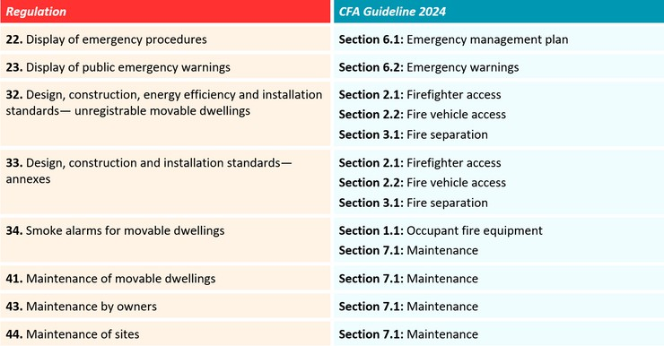

Appendix B: References and Resources

CFA Guidance
Please Note:
The Victorian fire services do not regulate gas, electrical or dangerous goods safety. Caravan park owners/operators or dwelling owners who require further information regarding these hazards within caravan parks should contact Energy Safe Victoria or WorkSafe.

CFA Website
- About Warnings
- Bushfire Safety for Workers
- Fire Danger Period Restrictions
- Renewable Energy Fire Safety
- Total Fire Bans and Fire Danger Ratings

CFA Publications
- CFA Design Guidelines and Model Requirements for Renewable Energy Facilities (2023)
- CFA Guidelines for the Provision of Emergency Information (2019)
- CFA Identification of Street Hydrants for Firefighting Purposes (2019)
- CFA Neighbourhood Batteries (2023)

Legislation
Building Regulations 2018
Dangerous Goods (Storage and Handling) Regulations 2022 Residential Tenancies Act 1997
Residential Tenancies (Caravan Parks and Movable Dwellings Registration and Standards) Regulations 2024 Victoria Planning Provisions

Australian Standards

Fire Protection Equipment
AS 2419.1-2021: Fire hydrant installations, Part 1: System design, installation and commissioning AS 2441-2005: Fire hose reels
AS 2444-2001: Portable fire extinguishers and fire blankets
AS 2941-2013: Fixed fire protection installations — Pumpset systems
AS 3786-2023: Smoke alarms using scattered light, transmitted light or ionization

Dangerous Goods
AS 1940-2017: The storage and handling of flammable and combustible liquids AS 2473.1-2006: Valves for compressed gas cylinders, Part 1: Specifications
AS 3780-2023: The storage and handling of corrosive substances AS/NZS 1596-2014: The storage and handling of LP Gas
AS/NZS 5601.1-2022: Gas installations, Part 1: General installations
AS/NZS 5601.2-2020: Gas Installations, Part 2: LP Gas installations in caravans and boats for non-propulsive purposes
Risk Management and Emergency Planning AS 3745-2010: Planning for emergencies in facilities AS/ISO 31000-2018: Risk management guidelines
SA/SNZ HB 89-2013: Risk management — Guidelines on risk assessment techniques

Electrical Safety
AS/NZS 3000-2018: Electrical installations (Wiring Rules)
AS/NZS 3001.1-2022: Electrical installations, Part 1: Connectable electrical installations and supply arrangements AS/NZS 3760-2022: In-service safety inspection and testing of electrical equipment and RCDs
AS/NZS 5139-2019: Electrical installations: Safety of battery systems for use with power conversion equipment

Other Relevant Guidance
EV Fire Safe
National Construction Code
Water Services Association of Australia (WSAA) Water Supply Code (2022)



CFA Caravan Park Fire Safety Guidelines 2024 Revision 2.3 (February2026)

